Summary Report

Observation from Data Analysis:

Tyusha Sarawagi & Sarah Wright

* 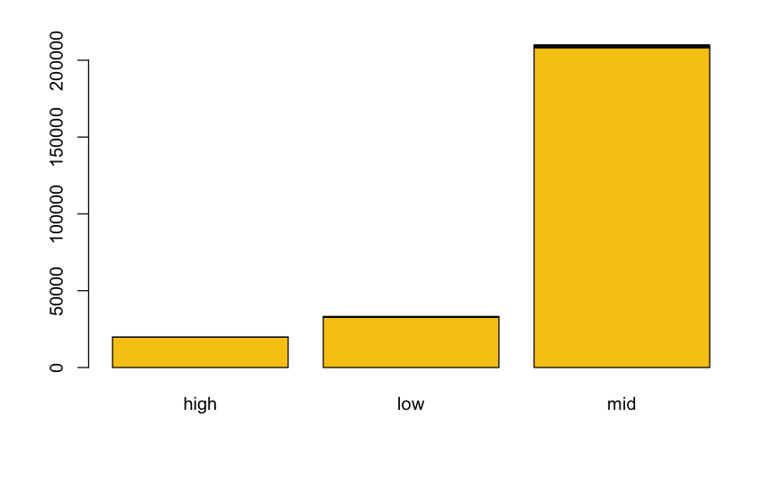Many people who inquire do not apply. Of the 10402 who inquired, only 2,432 people applied. This is approximately a 23.3% success rate using your current recruiting methods.
* Out of the 2,432 students who applied, 2,261 students were from metropolitan area and 171 students were from rural area.
* Most people who apply to college are in the middle-income demographic.

**Figure 1:** Bar chart that counts number of students who come from high, middle, or low-income families.

* 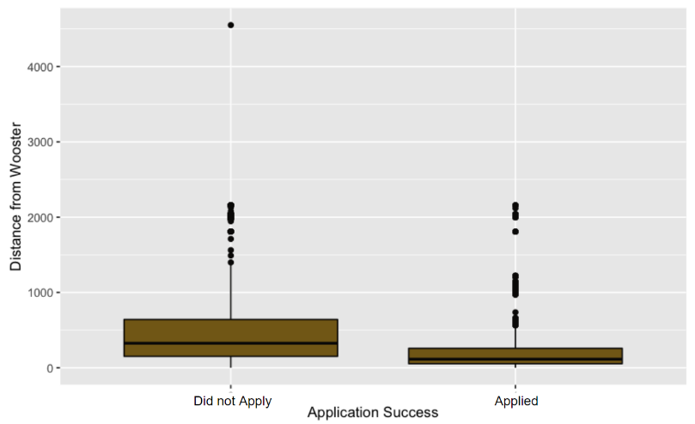Ohio, Pennsylvania, and Michigan have the highest application rates and all these states are close to OH. Therefore, we can say that people who live closer to Wooster are most likely to apply.
* Most people who applied to The College of Wooster live closer to Wooster and most people who have not applied to The College of Wooster live far from the college as you can see in figure 2.

**Figure 2:** Boxplot that compares how far do the students that apply to the college live.

* Out of the 2,432 students who applied, only 356 students were underrepresented minorities. This is approximately a 14.6% success rate using your current recruiting methods.

Proposed Solutions

* Based on this information, we propose if the Campus wants to increase their Diversity Efforts and thus the people who apply, therefore, we can channel our focus on particular groups like underrepresented minorities.
* We know that most people who apply to college are from middle income families. We can move forward with two approaches: either we can focus on the middle-income people as they are the once most likely to apply or they can try to bring more students from high income and low-income background by increasing financial aid.
* We say that out of 10,402 students who inquired, only 2,432 students applied, and 7,970 students did not apply. We could try and engage more with these students and better try to understand what their needs are.
* We could also reduce the cost of buying data by focusing mainly on the regions that are closer to the college. For instance, we have very few people from western states like California. So, if possible, we can have a more targeted approach while purchasing data.
* As mentioned earlier, majority of students who applied to the college are from Ohio, Pennsylvania, and Michigan. Therefore, we could focus more on these states and other states nearby.
* We could also engage more with the local community here in Wooster itself or in the neighboring cities.